CLEARED ORIENTATION

BARRIERS
Pantex generally has many construction sites across the plant at all times of the year. Barricading at construction sites is not necessarily universal and visitors should respect the boundaries of all types of construction barriers. Visitors without a specific work associated need should never approach an open excavation. Never cross a barricade without specific approval.

BUILDING ACCESS
Some facilities require a Q clearance for entry. Please follow all postings regarding facility clearance level.

CHEMICALS
Visitors and contractors must not bring any hazardous chemicals onto the Plant site without prior approval from Hazard Communication.

EMERGENCY PREPAREDNESS
Announcements are often made over the Plant loudspeaker system by the Emergency Operations Center (EOC) concerning weather warnings or instructions for off-normal events. The following are common protective actions that may be directed for Pantex personnel and visitors:
- Avoid the Area
- Shelter for Hazardous Material Release
- Shelter for Severe Weather
- Shelter for Security Event
- Active Shooter/Hostile Event
- Evacuation

These actions may be used individually or in combination, as the situation warrants. Please follow the instructions of Pantex Personnel if you have any questions as what to do in the event of a drill and/or emergency. If Personnel Accountability Procedures are announced, please contact the EOC at 477-5000.

ESCORT PROCEDURES
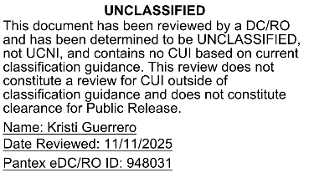
If you are escorted while on site, it is your responsibility to stay with the person escorting you at all times and you are expected to comply with your escort’s directions. You and your property, person, effects, vehicle, bags, containers, parcels and articles are subject to search and video surveillance. Do not touch, inspect, operate, move, repair, work, adjust, modify, measure, or use any tool or device on anything at Pantex unless your host authorizes you to do so. You will be questioned by your host on what tools, devices or equipment are in your possession. Use of any electronic, optical or mechanical measurement devices, or improvised devices, is prohibited without the specific authorization of your host. All personnel and property are subject to search at Pantex. Tell your host what tools or objects you are bringing, including any type of measuring instrument or object serving as a measurement instrument.

SECURITY
The Pantex Plant is responsible for maintaining the safety, security, and reliability of the nation’s nuclear weapons stockpile, and is entrusted with protecting a great quantity of classified information. Be aware that security procedures at the Plant are rigorous.

SECURITY BADGES
Badges must be worn, photo side out, at all times while on the Pantex site. The badge must be completely visible and worn above the waist on the outer most piece of clothing. If you have lost your badge or it is stolen, please contact Access Control, Bldg. 16-12, 477-3908 or 477-3909, or the Operations Center at 477-5000.

FOOTWEAR
Footwear shall meet the following requirements for entry into the Property Protection Area (PPA), Limited (LA), Protected (PA), or Material Access Areas (MAA):
- Heel height 2-1/2 inches or less, as measured at back of the heel.
- Heel width (side to side) ½-inch or more as measured at the tread surface.
- Foot fully enclosed.
- Non-skid soles shall be of sufficient thickness to prevent penetration.

Additional footwear requirements are defined for entry into specific facilities or areas and must be adhered to. Footwear such as sandals, flip flops, rubber sandals, open-toed, and high heels (greater than 2-1/2 inches in height and heel less than ½-inch diameter or width) shall not be worn in the Pantex facilities.

Exception: Footwear in the JCDC and other designated office areas in the PPA or directly within/direct access to the Limited Area shall meet the requirements above with the following exceptions:
- Footwear may include sandals as long as the upper part of the toes and heel are enclosed.
- Footwear with an open or “Peep Toe” style are acceptable.
- Employees are expected to wear footwear that is appropriate to a professional office environment.
- Specific work tasks in these facilities may require more substantial footwear depending on the hazards involved.
- Flip flops are not considered acceptable.

In inclement weather, employees are expected to wear footwear appropriate to the conditions. Line management, supervisors, subcontract technical representatives, and visitor hosts are responsible for communication and implementation of this policy and are to reinforce the importance of wearing safe and appropriate footwear. Personnel who have medical restrictions or special circumstances as it pertains to this policy will need to obtain site specific guidance on proper footwear from the Occupational Health Services (OHS).

RADIATION AREAS
Radiological postings are used to alert personnel of potential exposure to radiation. Personnel shall follow all radiological signs, postings, and labels. If personnel require entry into a radiological area, a dosimeter and further training may be necessary. Prior to entry, contact Radiation Safety Department at 477-5726 for access to Radiological Areas.

SMOKING POLICY
You may smoke inside your personally owned vehicle, but your used smoking materials must remain within the vehicle. Otherwise, smoking is allowed only in designated smoking areas where electric lighting devices are installed. No devices that can produce an open flame may be carried into the Limited Area, Protected Area or Material Access Area at Pantex (matches, lighters).

TRAFFIC SAFETY
Pantex encompasses a fairly large area that requires driving vehicles, so traffic safety is a major concern. Always wear your seatbelt. Because of special safety requirements, it is essential to obey all posted speed limits. Traffic monitoring is in effect. While a vehicle is in motion, cellular phone use by the driver is prohibited. If you are approached by any vehicle with flashing warning lights, pull over, stop completely, and let the vehicle pass. Remain stopped until all vehicles have passed. If you are following a group of vehicles with flashing lights, remain at least 300 feet behind. Never attempt to pass a convoy of vehicles or any vehicles with flashing lights!

EMERGENCY NUMBERS
General Emergency / Chemical Spill / Security 477-5000
Medical / Ambulance / Fire Department 477-3333

IDENTIFICATION OF PROHIBITED & CONTROLLED ITEMS
IMPORTANT:
Devices with camera, any Bluetooth capability, or any WIFI Hotspot capabilities are strictly prohibited from use at Pantex. The capabilities on the devices must be disabled when removed from personal vehicles on plant site. All activities involving controlled articles will be investigated and may result in disciplinary action, up to and including termination.

Prohibited Items
The following items are NEVER allowed ANYWHERE on-site at Pantex, unless prior authorization has been received from Safeguards & Security Division.
Any type or amount of the following:
- Alcohol
- Ammunition
- Arrows
- Blackjacks
- Chemical dispensing devices for pepper spray, mace, etc.
- Clubs
- Compound bows
- Controlled substances
- Crossbows
- Drug paraphernalia
- Drugs (prescriptions are allowed as long as they are prescribed for the employee who is using them. Medical must be notified of medication use.)
- Explosives

Controlled Items
The following are examples of controlled items that are allowed on-site at Pantex, but MUST remain in personal vehicles in the Property Protection Area.

Any type or amount of the following:
- Cameras – At no time are pictures to be taken anytime on plant site with any type of personal equipment.
- Telephones (all types including cellular, and satellite)
- Computer Components
- Cellular wireless cards
- Wireless cards

Exception: Wireless cards issued for Pool Laptops in transit between 16-19 and your car
- Any device with Bluetooth capability
- Any other computer component or peripheral
- Computers not owned by Pantex – Exceptions for this category are given on a case-by-case basis by the Information Systems Security Site Manager (ISSM) or their designate
- Laptops/Netbooks
- Smart phones/PDAs (i.e., iPhones)

Basically – if you can plug it in, if you can upload, download, or transmit information with it, leave it in your personal vehicle in the Property Protection Area.

NOTE: Government-owned equipment must be pre-approved and documented before it can be brought onto the plant site. Employees planning to purchase electronic equipment for use at work should contact the Technical Security Office prior to purchase. Electrical Devices are not permitted into a Nuclear Facility with the exception of non-transmitting watches, non-transmitting pagers, RSA tokens (model SID700 only), Pantex-issued pedometers, hearing aids, and internal medical devices that do not have defibrillator capabilities. All other electrical devices or medical equipment should be reported to Pantex escorts to identify allowable facilities.

NOTE: Pantex issued pagers are the only authorized pagers allowed for sitewide use. All other pagers (government or personally owned) must be evaluated and approved through the Pantex technical review process.
- Explosive devices
- Fertilizer
- Firearms
- Illegal drugs
- Incendiary devices
- Items that could be used to manufacture explosives
- Knives with blades 2.5 inches and longer
- Knuckles
- Nightsticks
- Nun chucks
- Stun guns
- Swords
- Technical Surveillance Equipment (i.e., any equipment specifically designed to clandestinely collect information)
- Zip guns
- Media players (i.e., iPods)
- Tablets, pads, and slates (i.e., iPads)
- Game devices (i.e., PSPs)
- Any other device with a processor and storage
- Global Positioning Systems (GPS) – (e.g., Portable (Transmit/Receive))
- On-Star
- Personal software
- Radio frequency (RF) devices (Note: key fobs ARE allowed except in Nuclear Explosive Areas)
- Recording devices (optical, video, audio, or data)
- XM or Sirius radio receivers with recording capabilities
- Any privately owned device, electronic or optical, capable of recording, processing, storing or transferring audio, computer data, video or photos.

OPSEC & PUBLIC INFORMATION RELEASE
Only a limited amount of Pantex information may be released. For items such as professional publications, statements of work, occurrence reports, photographs, etc., you must submit an Information Release Office (IRO) request online for proper approvals (MNL-352367). If you are granted access to RD and SNM in connection with a classified visit, you must protect this information and material, and you do not have access to Pantex classified or SNM after your visit period ends. You are subject to all DOE or Other Government Agency clearance reporting requirements while you are at Pantex and must notify your host of any event or condition that is reportable by cleared personnel, including but not limited to any arrest or detention and any change to your name or immigration status. You are reminded only those Pantex employees that have been specifically designated to speak for Pantex to the media are authorized to do so. If you are contacted by any media personnel for your comments on Pantex information, you are directed to refuse the request, and recommend that they contact the Pantex Public Affairs Department (WI 02.04.08.01.01). Also, use appropriate shred boxes for paper waste. Do NOT dispose of paper in business trash or dumpsters. Information found in the public domain to be sensitive to Pantex or Pantex employees will be handled according to Federal Law, DOE Orders, and the Pantex Employee Manual (MNL-00018). Acts of misconduct, neglect and/or unauthorized public disclosures about Pantex are strictly prohibited and may result in criminal and/or civil penalties.

Violations may also result in disciplinary action by the Company up to, and including, termination.

To Summarize:
- You are prohibited from disclosing Pantex information without approval
- For public release authorization, you must have the content reviewed by submitting an IRO request
- You are prohibited from placing/releasing Pantex information in the public domain (e.g., Facebook, Twitter, LinkedIn, or any other social media platform or app or messaging app, trash, dumpsters, restaurants, stores, personal travel, home, etc.)
- Pantex information not approved for public release may include but is not limited to:
- Classified information
- Controlled Unclassified Information (CUI), (e.g., UCNI, ECI or PII)
- Critical Program Information (CPI) (e.g., capabilities, weaknesses, events, equipment, schedules, production, problems with meeting goals, certain security data, etc.)
- Information pertaining to plant production (schedules, problems with meeting goals, etc.)
- Rumors

If you have any questions pertaining to OPSEC or Public Information Release, please contact Information Security at 477-6000.

EXPLOSIVE HAZARDS & IDENTIFICATION
Pantex performs a significant amount of work involving explosives. Regardless of your job position or work station location, while you are physically at Pantex, you will be exposed to potential explosives hazards should there be an explosives accident.

Explosives hazards consist mainly of what we call “blast” and “fragment.” Blast (overpressure) can cause serious injury or death. It can also cause damage to eardrums, the sinuses, and the lungs. Fragments can cause impact or penetration damage to the body. The seriousness of these injuries is dependent on the amount and type of explosives, structures, and one’s specific location in relation to those explosives.

Explosives buildings and areas at Pantex can be identified by the presence of large orange placards or fire symbols. This is what they look like:



Shipments/packages of explosives can be identified by diamond-shaped orange placards such as these:
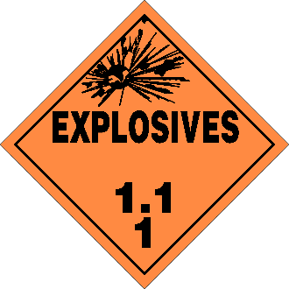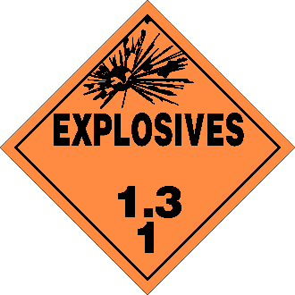
Exclusion Areas
Exclusion Areas are specific physical locations where people are not protected from explosives hazards, which can cause serious injury or death. For this reason, no personnel are allowed in active Exclusion Areas during explosives operations. You will recognize an active Exclusion Area by a combination of the following physical barriers and visual/audible warnings:

- Gates blocking your way
- Chains blocking your path
- Roadblocks
- Warning signs (Danger, Hazardous Operation, Do Not Enter While Lights are Flashing or Area Barricaded)
- Flashing lights
- Sounding horns

If you approach an area where the gates are closed and posted with signs, or chains are across the way and posted with signs, or road blocks are in place, or warning lights and/or horns are flashing and sounding… DO NOT ENTER, and DO NOT ALLOW others to enter. Should you observe someone in an active Exclusion Area, advise them to leave the Exclusion Area immediately, then notify the Operations Center at ext. 5000.

Do Not Touch Explosives unless you are trained and qualified BY PANTEX to do so. Please be aware that although you may be qualified to work with explosives at another DOE/NNSA Site, that does not mean that you are qualified to work with explosives at Pantex.
Pantex Explosives Workers undergo extensive training and qualification to perform their explosives tasks safely. Once qualified, they work to approved explosives operating procedures that have been extensively vetted through hazard analysis, subject matter expert review, and operational readiness activities.
Pantex Operational Supervisors verify daily that Pantex Explosives Workers are up to date on their training and qualification prior to their performing explosives operations.

Comply with Posted Limits Placards
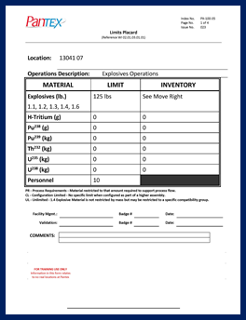
Limits Placard
Limits Placards are posted on or near each explosives bay or room door, specifying explosive limits, nuclear material limits, and personnel limits along with related safety precautions that should be observed in these locations.
When you approach an explosives bay or room, always read the Limits Placard, and check to see how many personnel are already in the explosives bay or room. If the personnel limit is already met, wait for someone to leave prior to entry.
Never enter an explosives bay or room if it would exceed the personnel limit posted on the Limits Placard.

Responding to Explosives Moves
Should you encounter vehicles with flashing lights while driving on Pantex roadways:
- If following from the rear, DO NOT PASS, but rather maintain a distance of approximately 300 feet from the vehicle(s).
- If approaching from the front, pull to the side of the road when the vehicle(s) get within 300 feet.
- Once the vehicle has passed and a separation distance of 300 feet has been accomplished, continue on your way.

Should you encounter a forklift move (often accompanied by a walker/spotter) in Pantex ramps:
- If following from the rear, DO NOT PASS, but rather maintain a distance of 25 feet from the forklift.
- If approaching from the front, pull to the side of the ramp, corridor, or hallway.
- Follow the directions of the walker/spotter (if present).
- Once the forklift has passed and a separation distance of 25 feet has been accomplished, continue on your way.

Electric and Plug-in Hybrid vehicles with energy storage devices based on lithium battery chemistries

DO NOT take Electric or Plug-in Hybrid vehicles into the Limited Area.  DO NOT park electric vehicles within 30 ft of buildings. | 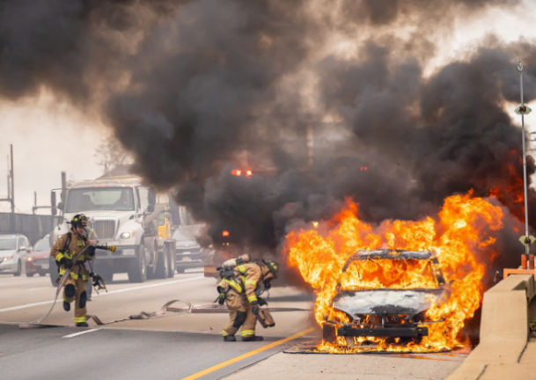  Electric Vehicle Fire

